**Assignment 27.6**

**Problem Statement:**

Using the below given two datasets you need to give a demo on the below joins in hive.

* Bucket Map join
* Sort-Merge Bucket join
* Sort-Merge Bucket Map join
* Left semi join

**Input:**

You can download the datasets from the below link:

<https://drive.google.com/open?id=0ByJLBTmJojjzSWhfXzI5NGh4RGM>

Dataset description of dataset1.csv is as follows:

id,first_name,last_name,email,gender,ip_address

Dataset description of tdataset2.csv is as follows:

id,first_name,last_name

**Output:**

Creating tables ds1 & ds2 and loading dataset1 and dataset2 into the tables.

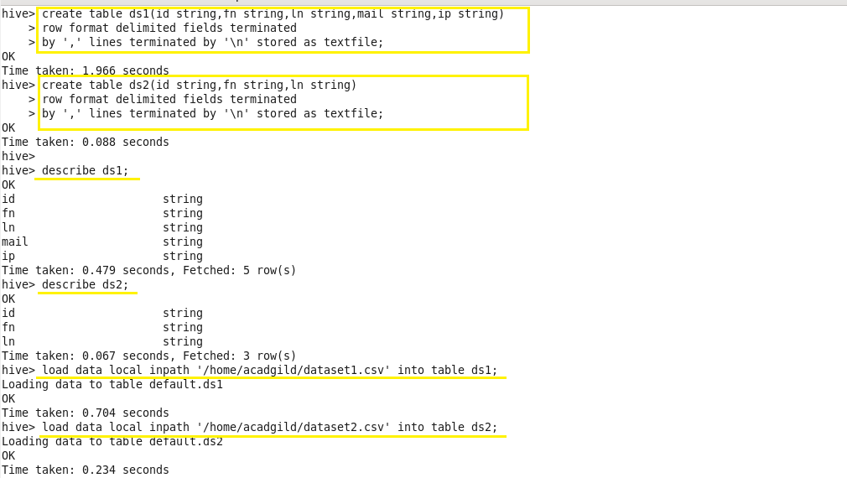

* **Bucket Map join:**

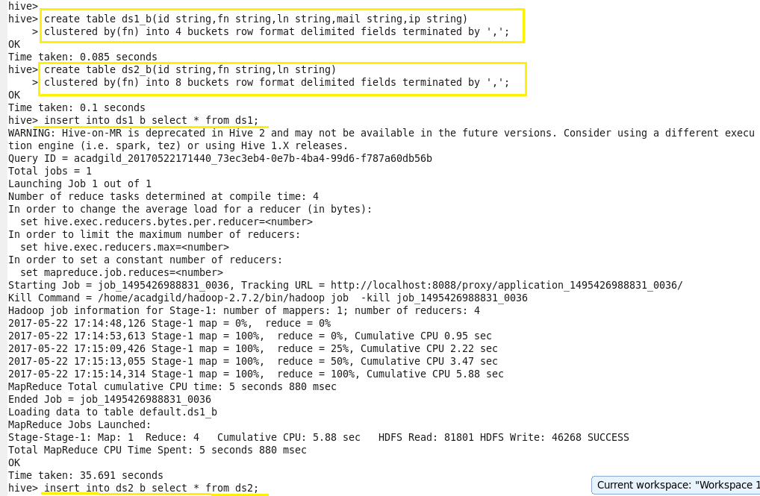

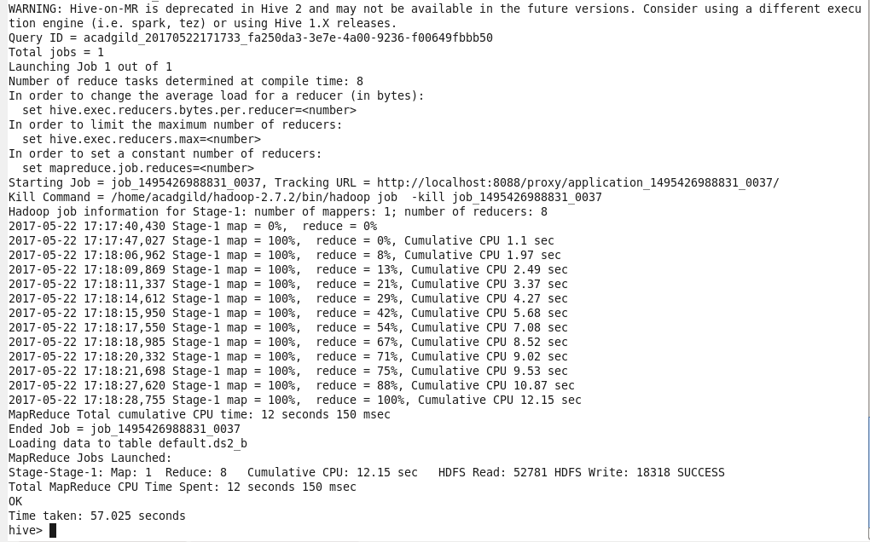



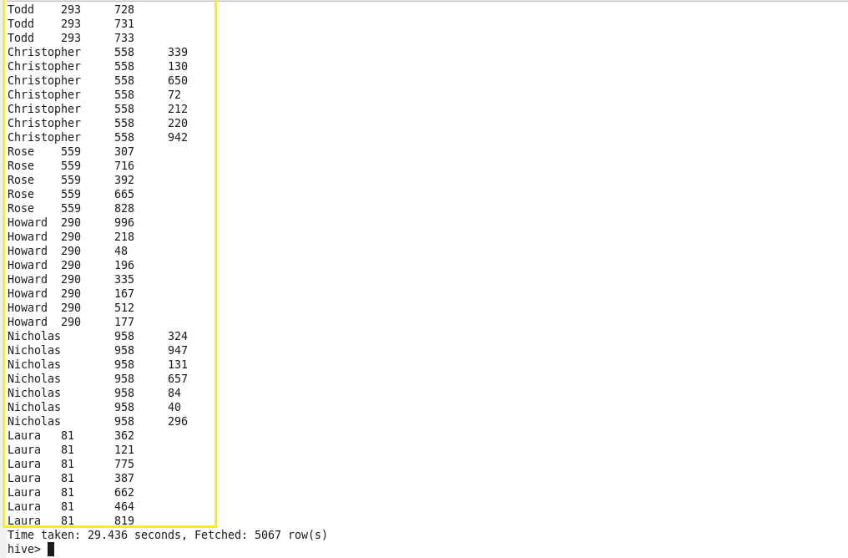

* **Sort-Merge Bucket join:**

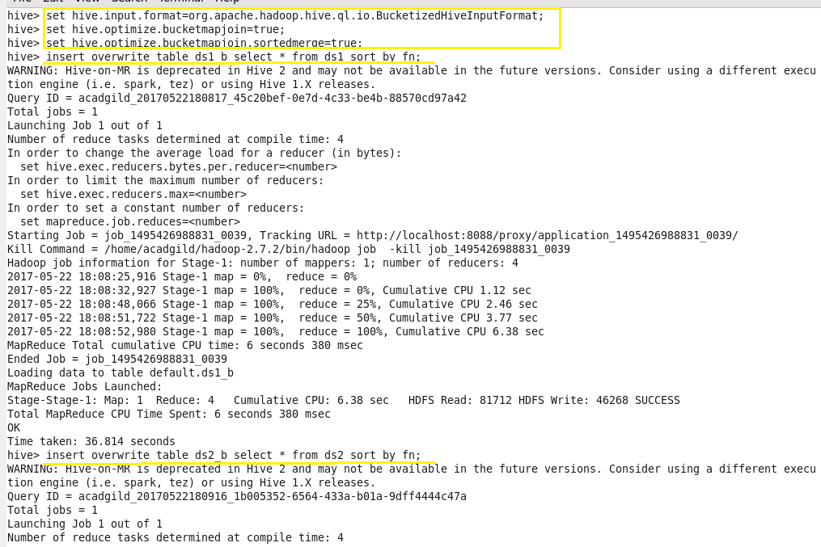

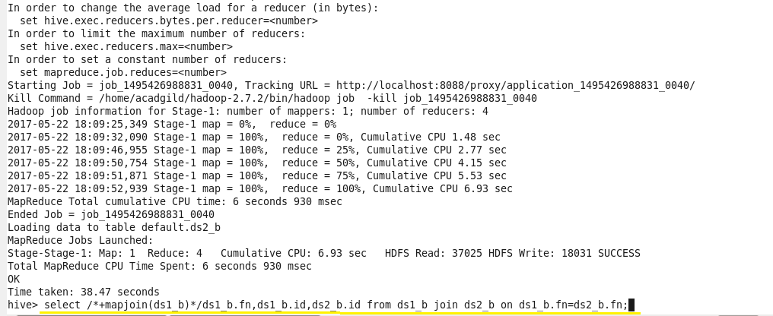

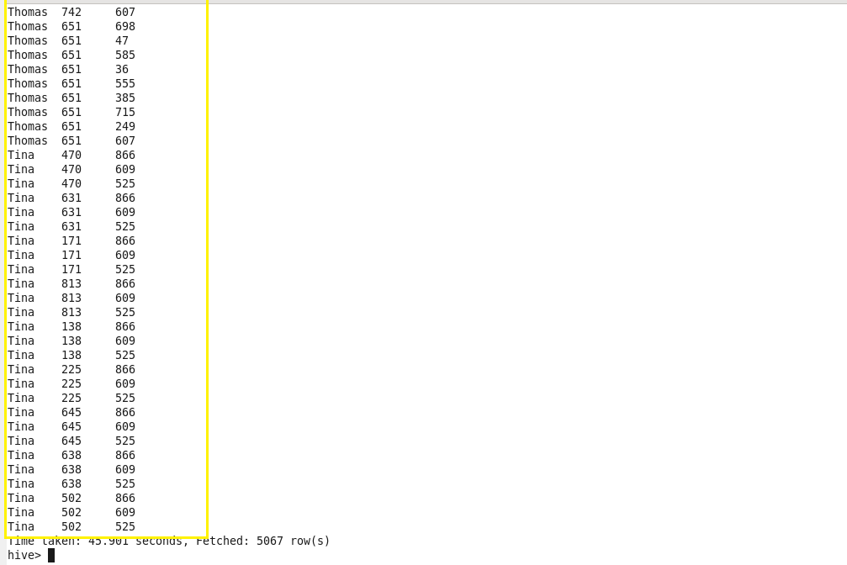

* **Sort-Merge Bucket Map join:**

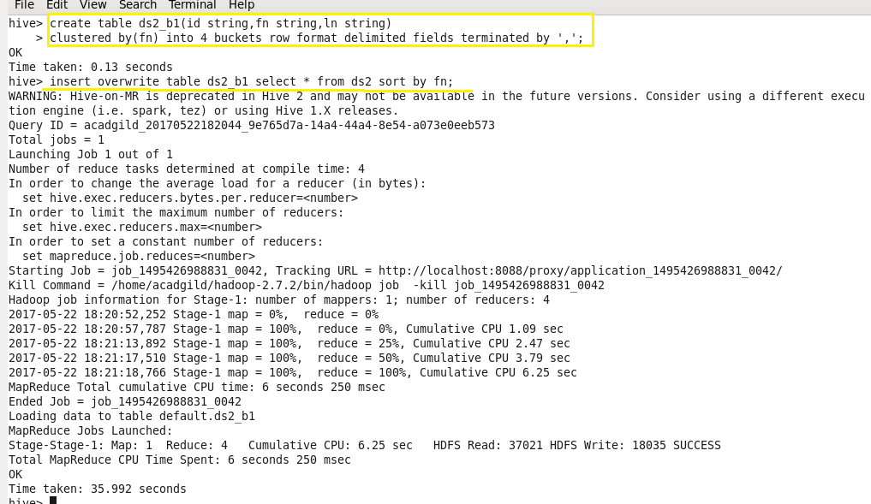



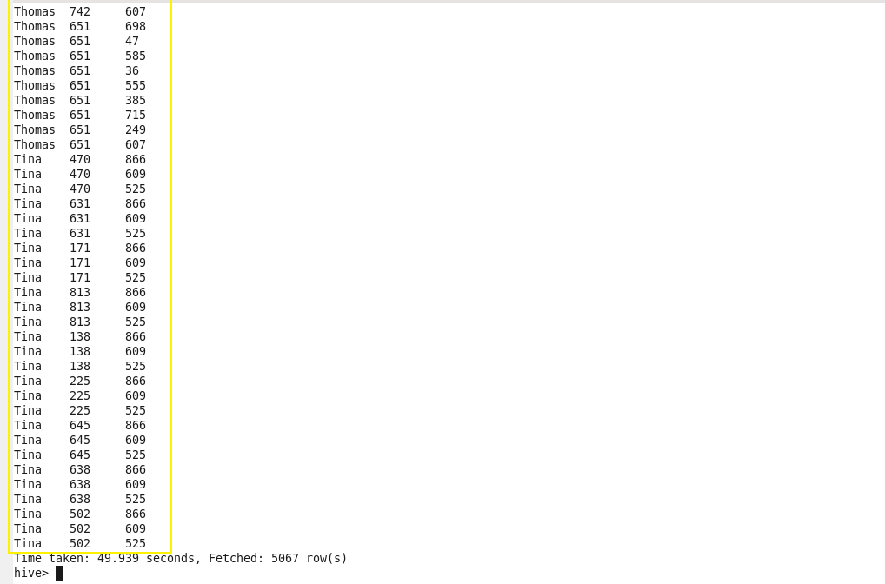

* **Left semi join:**

